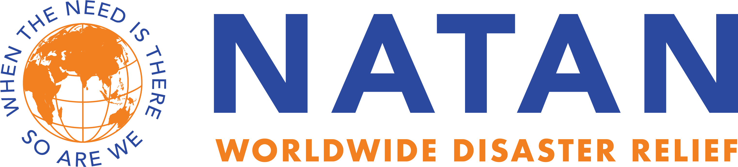

Stephen L. Stulman
NATAN Advisory Board

Steve Stulman is a long-time Zionist, having visited Israel more than 65 times over the past 55 years. He has been deeply involved as a lay leader in almost every aspect of Jewish communal and American-Israeli life, from the National Young Leadership Cabinet of the UJA to the America-Israel Chamber of Commerce and as Deputy Chairman and Treasurer of The Board of The Weizmann Institute of Science in Rehovot, Israel.

His special interest during the past decade has been the promotion of Israeli Judaism as an alternative to secularism or orthodoxy, especially through the creation of independent, pluralistic, egalitarian new Jewish communities and organizations such as Beit Tefilah Israeli in Tel Aviv, Nigun Halev in the Jezreel Valley and the Beit Midrash Israeli in Jerusalem. He has also tried to enhance the visibility of these organizations through the use of professional public relations and has recently helped to promote the visibility of NATAN.

Steve earned a B.A. from Yale University and served as an officer in the U.S. Naval Reserve. He spent his business career as an executive in the lumber distribution industry and lives in New York City.

